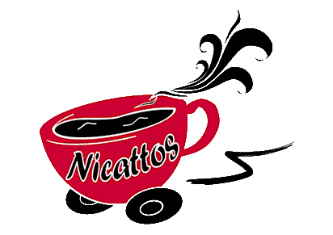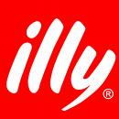
Drinks Menu

Latte £1.80 Macchiato £1.50
Cappuccino £1.80 Cadbury's Hot Chocolate £1.80
Mocha £1.80 White or Dark Hot Chocolate £1.80
Espresso £1.30 'Rocket Fuel' £2.00
Americano £1.70 (4 shot Americano!)
Flat White £1.80 Tea (Ordinary or Flavoured) £1.30

Add an extra shot of espresso for 20p, Add Marshmallows and cream for 20p!
Use your own mug and save 10p. Flavoured sprinkles available on request.
If you would like to make your coffee ‘skinny’ please ask when ordering
Large 16oz Drinks 30p extra (3 shots of espresso)

Flavoured Syrups (Coftails):-
Try one of our extensive range of syrups in your coffee or hot chocolate to make a coffee cocktail or 'coftail' for only 10p (They are the only cocktail you can drink at work!!)

Vanilla Caramel Fudge Hazelnut
Chilli Caramel Chilli Chocolate Chilli
Almond Mocha Mocha Mint
Mocha Orange Mocha Caramel Chai
Amaretto English Toffee Butterscotch
Toffee Apple Cranberry Gingerbread
Toasted Marshmallow Secret Squirrel Cinnamon
Sugarfree Vanilla Sugarfree Caramel Egg Nog

Smoothies*

We stock a freshly made smoothie every day (various flavours) £2
All our smoothies contain 2 of your recommended 5 a day intake of fruit and vegetables. *Only available in summer

Snacks Chilled Drinks
Assorted Flapjacks £1
Double Choc Muffin £1 Mineral Water 80p
Lemon & Poppyseed Muffin £1 Irn Bru Can 80p
Blueberry Muffin £1 Diet Irn Bru Can 80p
Raspberry & White Choc £1 Coke Can 80p
Mars Crispie Traybake 70p Diet Coke Can 80p
Munchies Tiffin 70p Sunkist Berry 80p
Caramel Shortbread 70p Sunkist Orange 80p
Rocky Road Crunch 70p
Mint Aero Tiffin 70p
Coconut & Raspberry Slice 70p We strive to stock as many of the
Sea Salt & Vinegar Crisps 70p drinks and snacks as possible Mature Cheddar and Onion 70p on a daily basis. We also have
Peri Peri Chicken Crisps 70p different special offers from mont to month, please ask for our latest offers or look out for our special menu. Our traybakes and cookies are all home-made.

Homemade Ice-cream (Only in summer months)

Strawberry Raspberry Chocolate Orange Chip Frozen Yoghurt

All available in two scoop tubs for £2/each

Nicattos also stock a range of sandwiches, baguettes, bagels and rolls on a daily basis as well as home-made soups if you would like to be added onto our daily specials distribution email list please email david@nicattos.co.uk

